Alan Varkey Martin

2437007

Code 1:

SELECT *

FROM crime_scene_report

LIMIT 5;

Output:

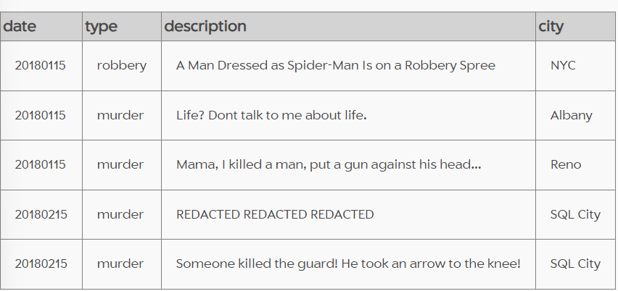

Code 2:

SELECT *

FROM crime_scene_report

WHERE type = "murder";

Code 3:

SELECT *

FROM crime_scene_report

WHERE type = "murder"

AND date = 20180115

AND city = "SQL City";

Output:

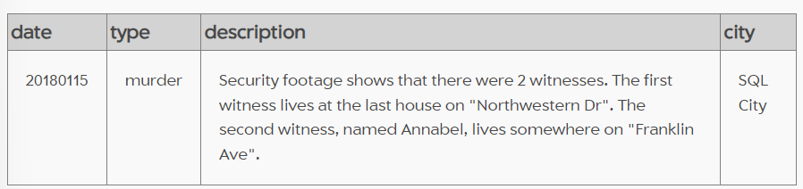

Code 4:

SELECT *

FROM person

LIMIT 5;

Output:

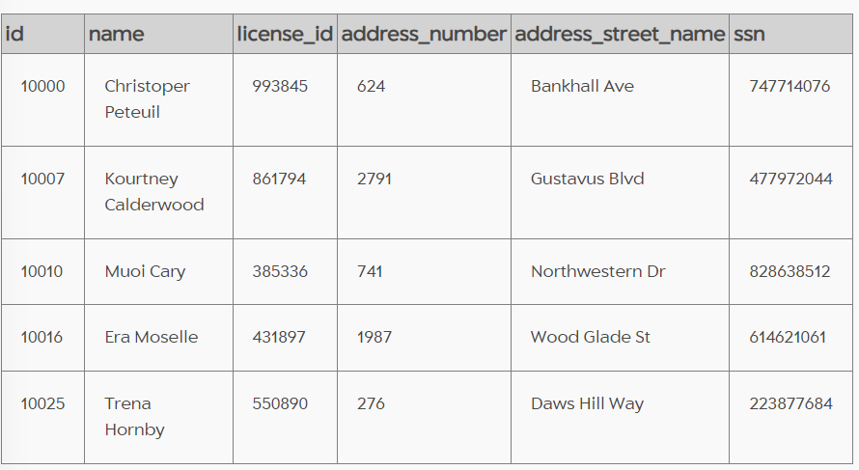

Code 5:

SELECT *

FROM person

WHERE address_street_name = "Northwestern Dr"

ORDER BY address_number DESC;

|  |  |  |  |  |  |
| --- | --- | --- | --- | --- | --- |
| 14887 | Morty Schapiro | 118009 | 4919 | Northwestern Dr | 111564949 |

Output:

Code 6:

SELECT *

FROM person

WHERE name LIKE '%Annabel%'

AND address_street_name = "Franklin Ave";

Output:

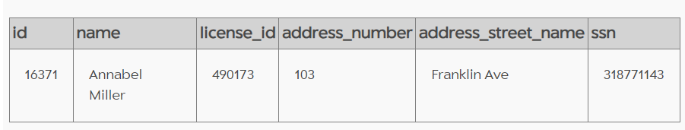

Code 7:

SELECT *

FROM interview

WHERE person_id IN ("14887", "16371");

Output:

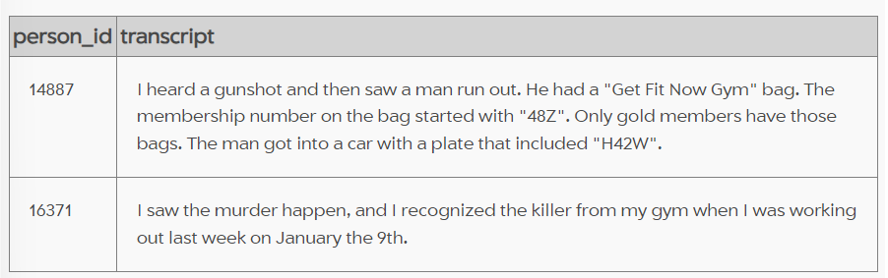

So, here's our clues:

* Murderer is a man and a member of a gym called "Get Fit Now Gym" and has a gold membership no. starting from "48Z".
* He was working out at the gym on 9th Jan.
* He drives a car with car plate containing "H42W".

Code 8:

SELECT *

FROM get_fit_now_check_in

WHERE membership_id LIKE '48Z%'

AND check_in_date = "20180109";

Output:

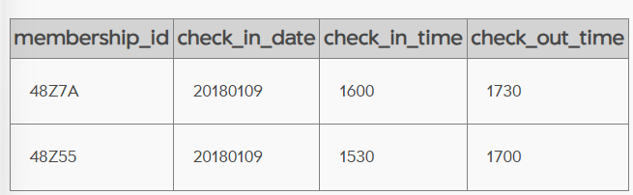

Code 9:

SELECT *

FROM drivers_license

WHERE gender = "male"

AND plate_number LIKE '%H42W%';

Output:

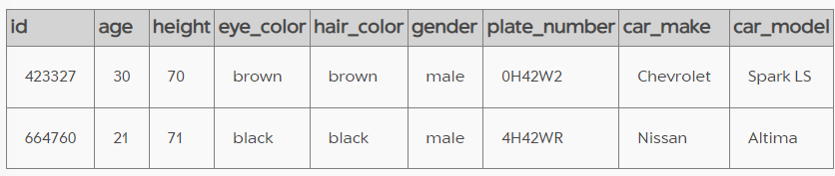

Code 10:

SELECT *

FROM person

WHERE license_id IN ("423327", "664760");

Output:

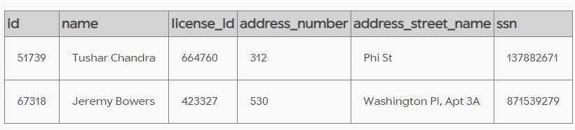

Code 11:

SELECT *

FROM get_fit_now_member

WHERE person_id IN ("51739", "67318");

Output:

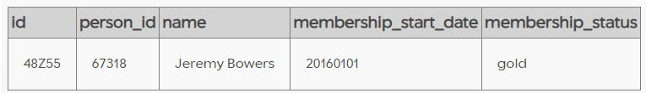

Jeremy Bowers is the Murderer.

THE FINAL SOLUTION

